Azure services

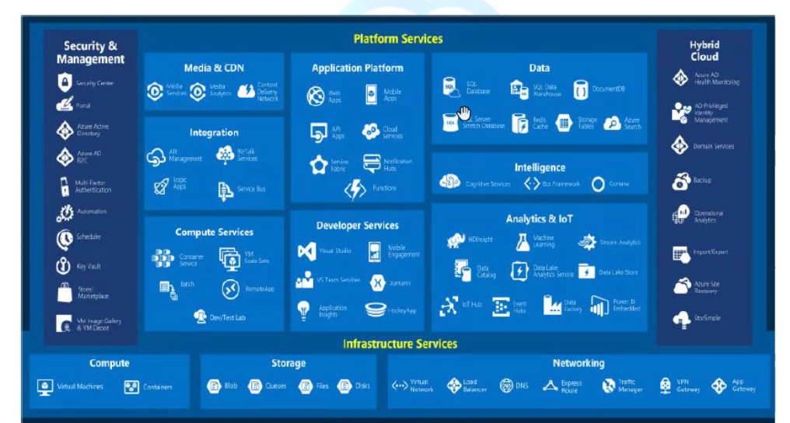

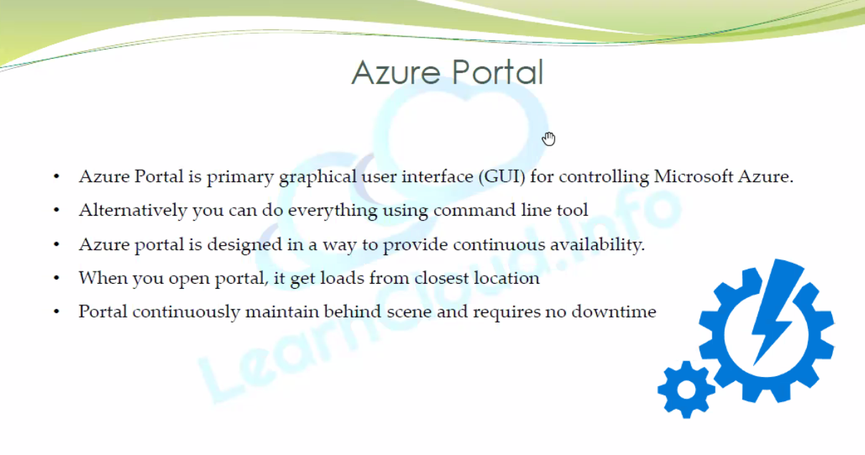

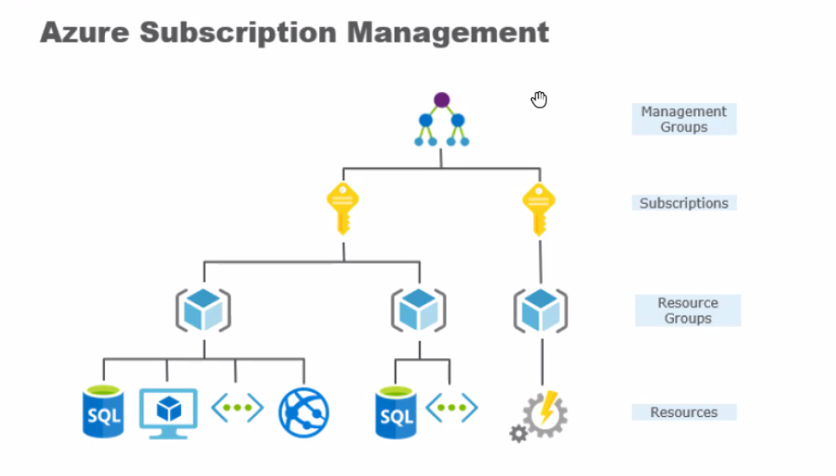

Storage

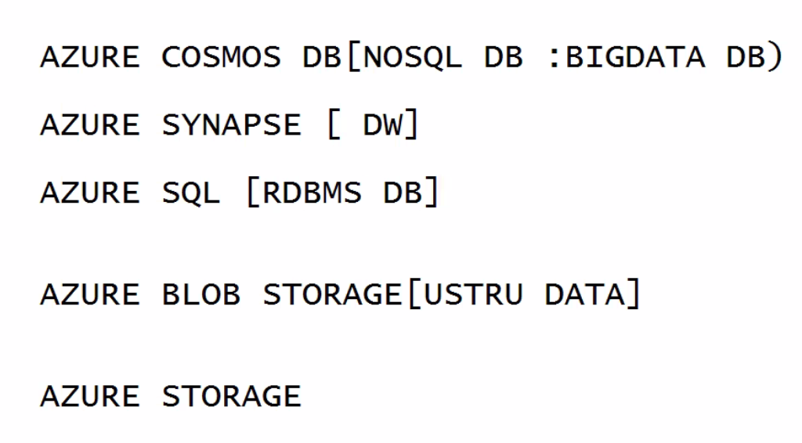

Please follow the steps in the Azure guidelines issued by the vendor

Configure - creds

Username - shubdutta

Login password – AIacademy21(for all)

